4-to-1 Multiplexer (MUX):

The 4-to-1 multiplexer is a circuit that takes in 4 inputs and sends a signal out depending on which select gate is switched on or off.

Gate Implementation:

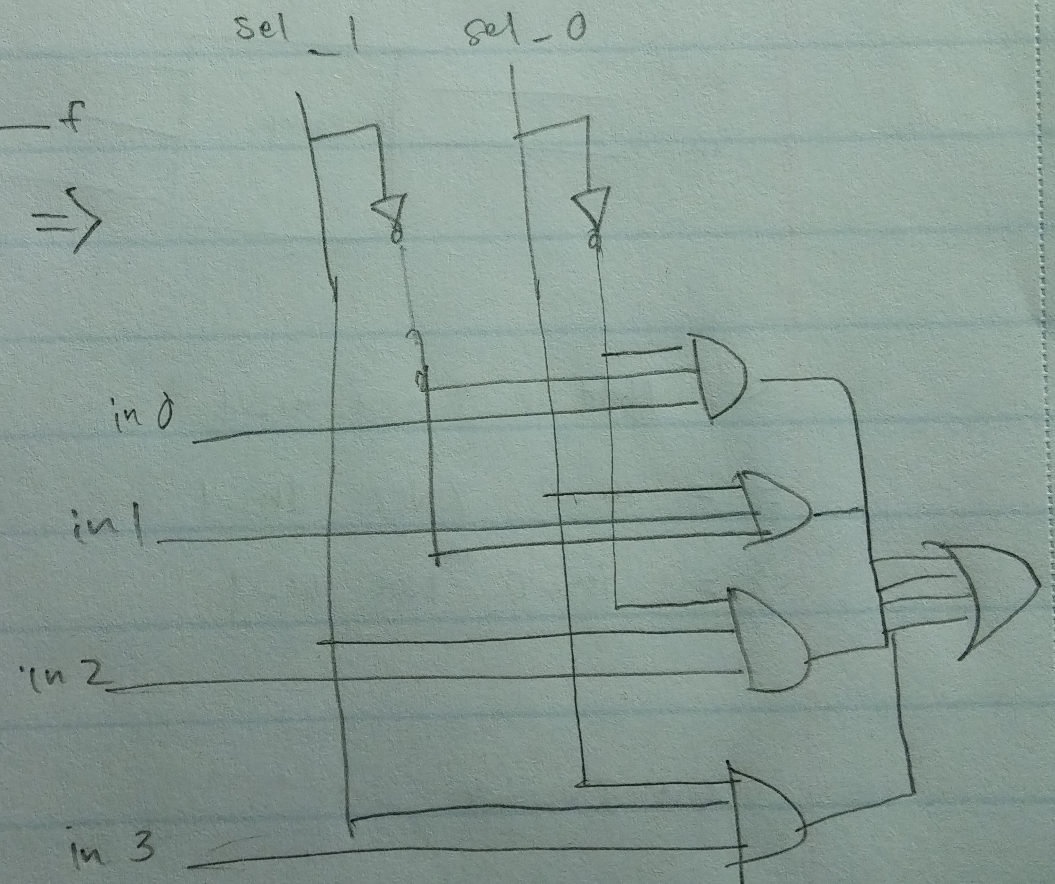

Truth Table:

|  |  |  |
| --- | --- | --- |
| **Sel_1** | **Sel_0** | **f** |
| 0 | 0 | In_0 |
| 0 | 1 | In_1 |
| 1 | 0 | In_2 |
| 1 | 1 | In_3 |

K-Map; Boolean Expressions:

f = (in_0*sel_0’*sel_1’) + (in_1*sel_0’*sel_1) + (in_2*sel_0sel_1’) + (in_3*sel_0*sel_1)

|  |  |  |
| --- | --- | --- |
| **Sel_0**  **Sel_1** | **0** | **1** |
| 0 | In_0 | In_1 |
| 1 | In_2 | In_3 |

Waveforms:

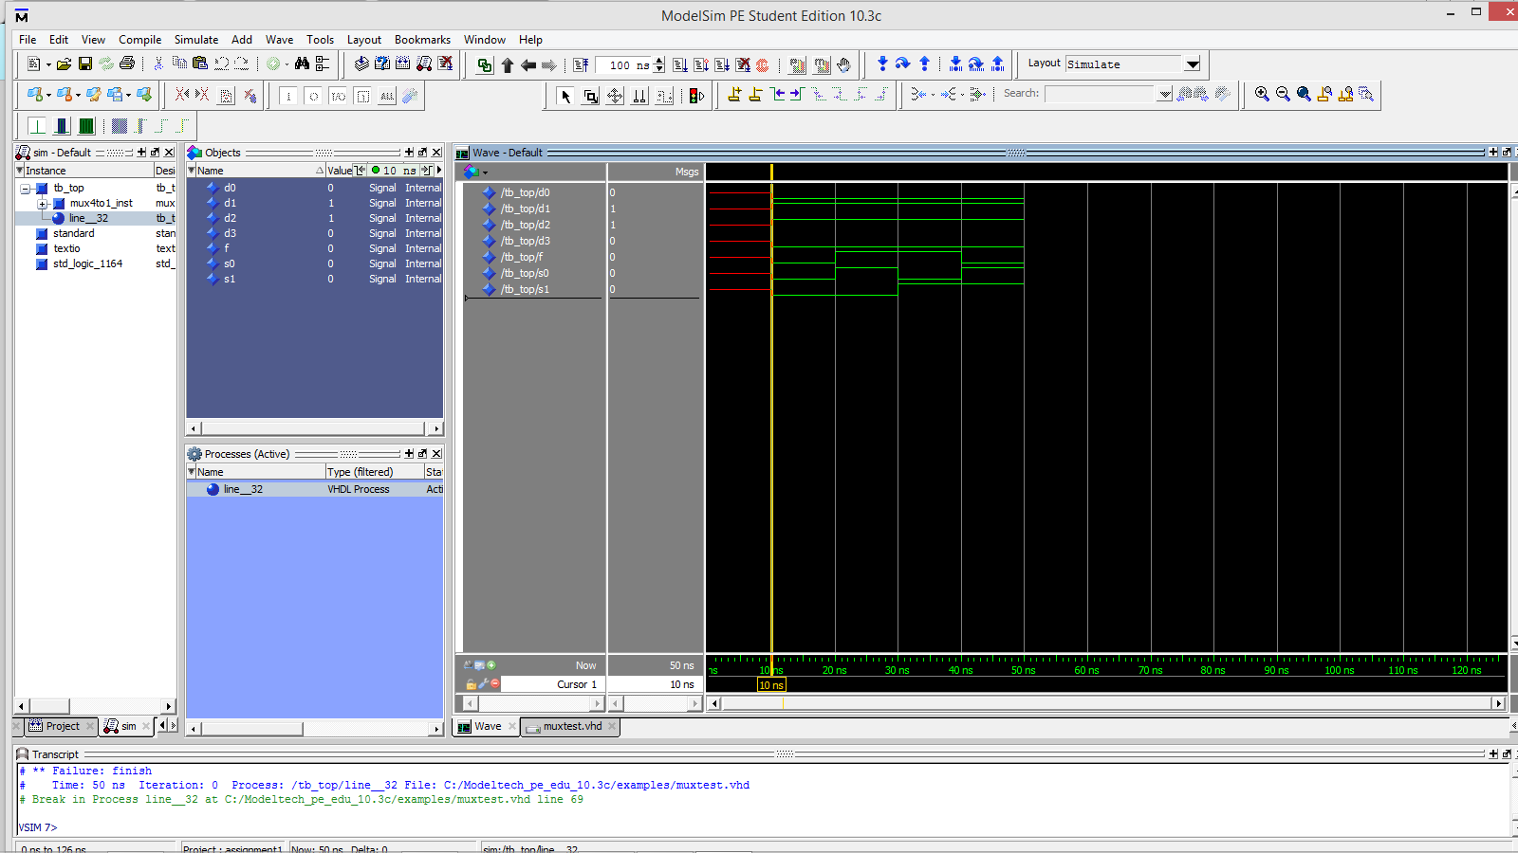

Full Adder/Subtractor :

The full adder and subtractor is a circuit that takes in 2 1-bit binary numbers and either add or subtract them depending on the signal which the circuit is designed to choose. In my circuit 0 is add and 1 is subtract. What makes a fuller adder and subtractor different from the half adder and subtractor is that in a full adder and subtractor, carry ins and carry outs are taken in consideration during the mathematical process.

Gate Implementation:

Full Adder Gate:

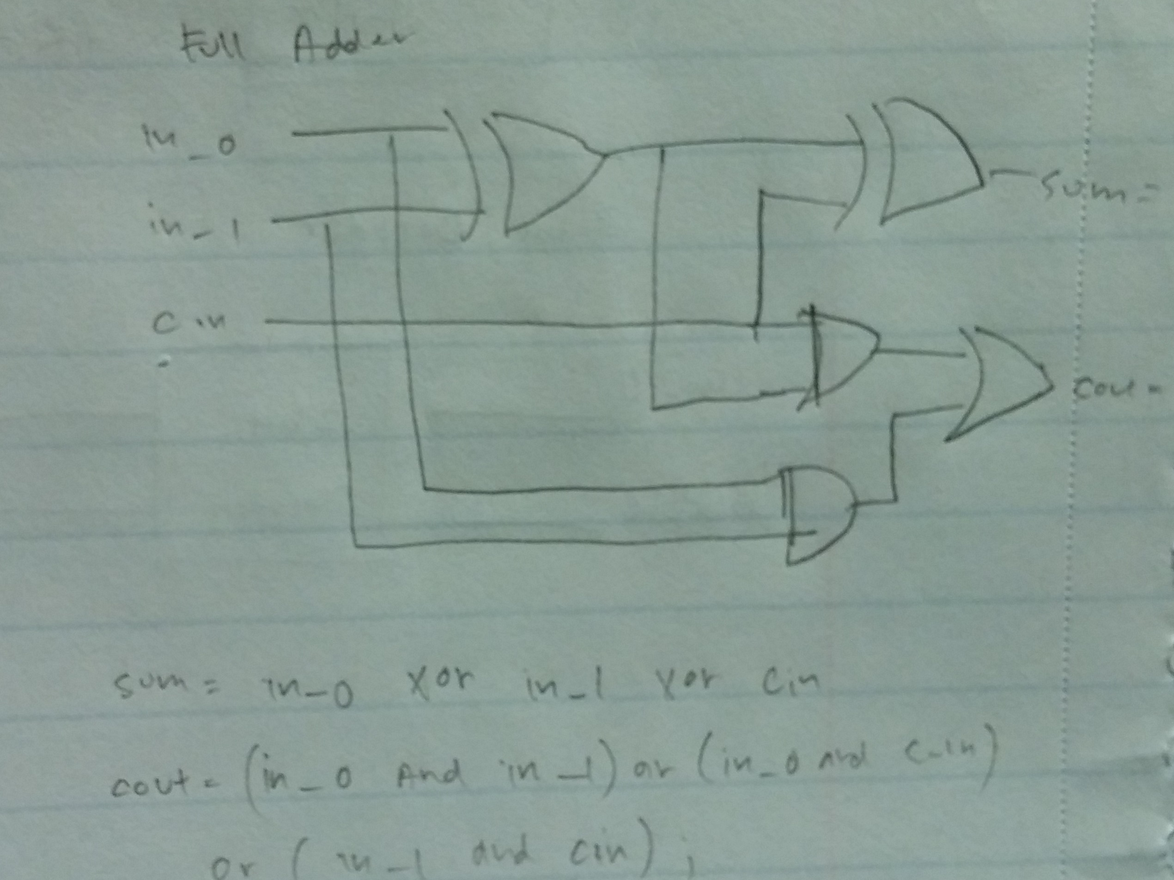

Full Subtractor Gate:

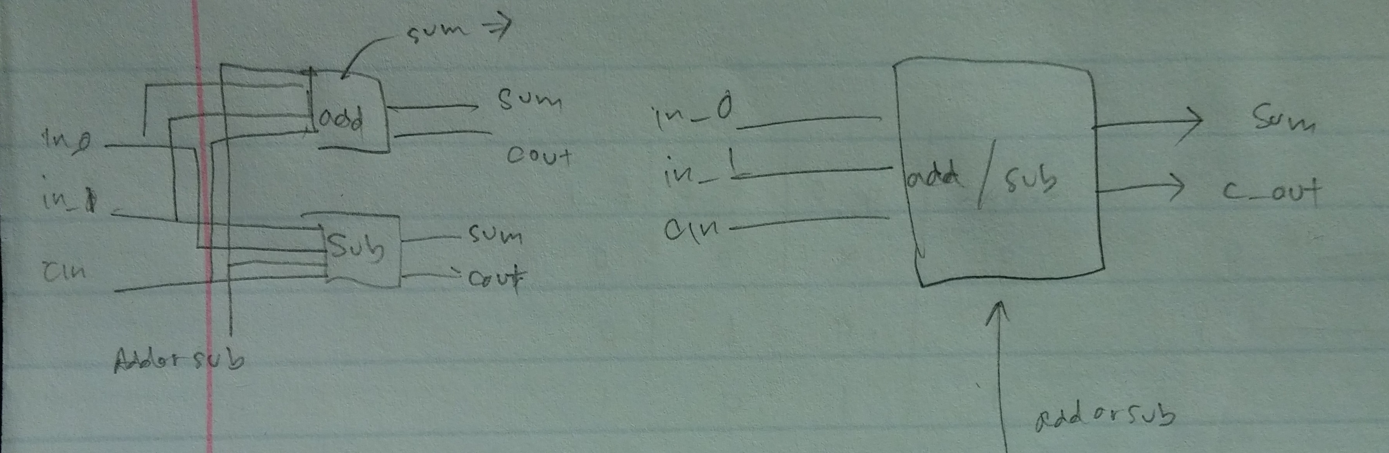

Truth Table :

Adder



Subtractor



K-Map

Boolean Equations:

Full Adder:

Sum = in_0 xor in_1 xor cin

Cout = (in_0*in_1) + (in_0*cin) + (in_1 *cin)

Full Subtractor:

Sum = in_0 xor in_1 xor cin

Cout = (in_0’ * in_1) + (in_0’ * cin) + (in_1 * cin)

Wave map:

:

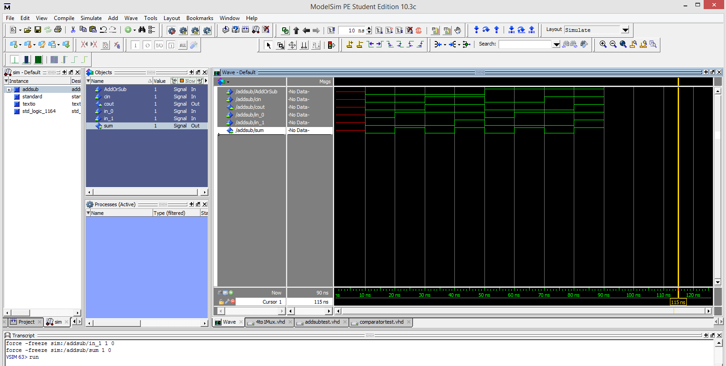

Comparator:

The comparator is a circuit that compares two 1-bit numbers and sends a signal through the gate corresponding to whether the 1st bit is either greater than, equal to, or less than the 2nd bit.

Gate Truth Table K-Map

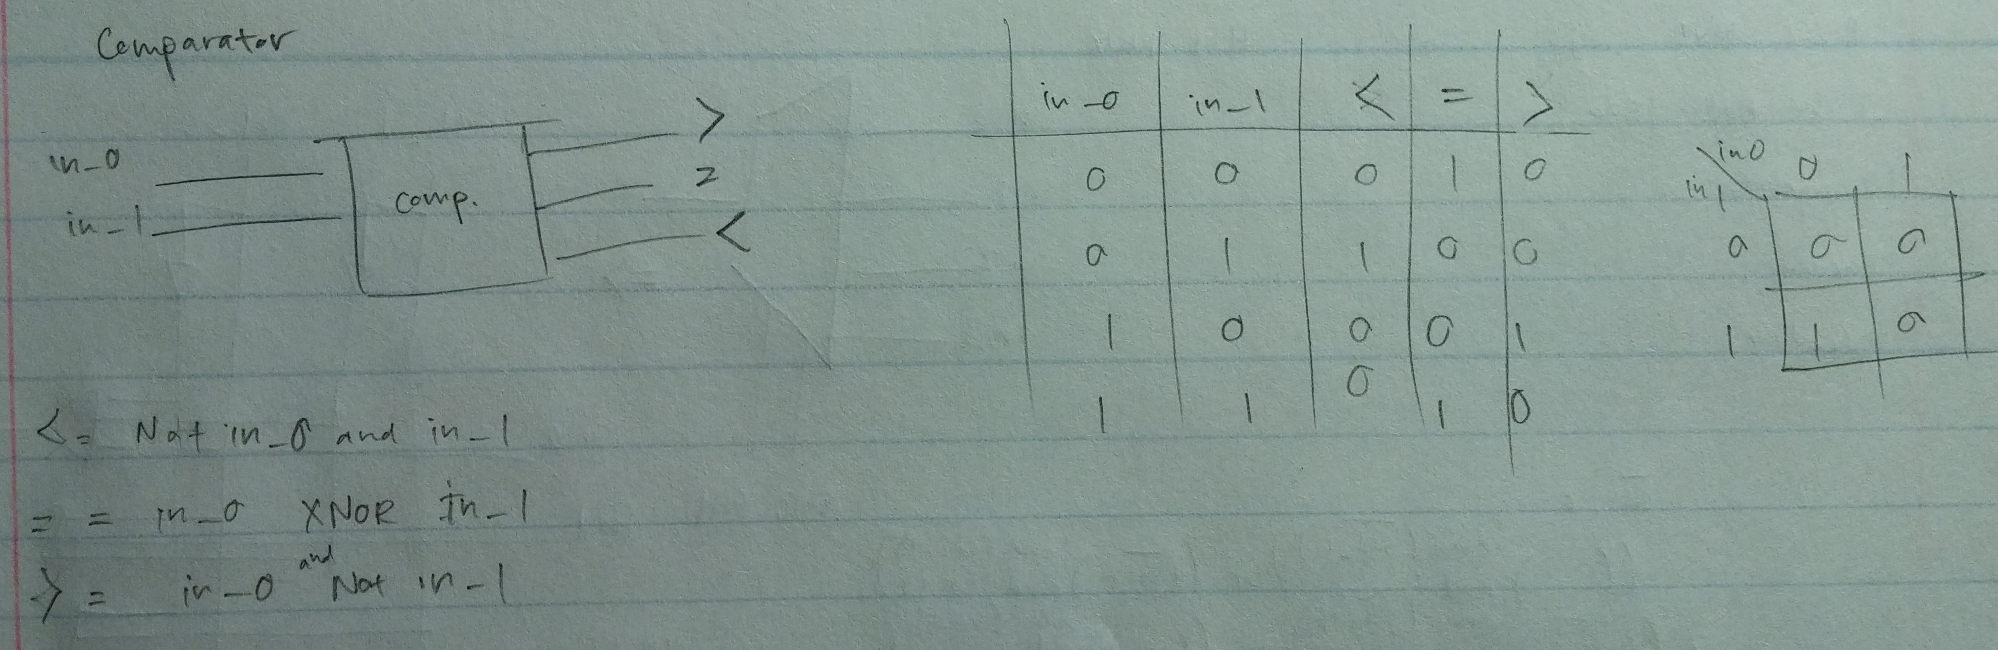

Boolean Equations

Wave Map:

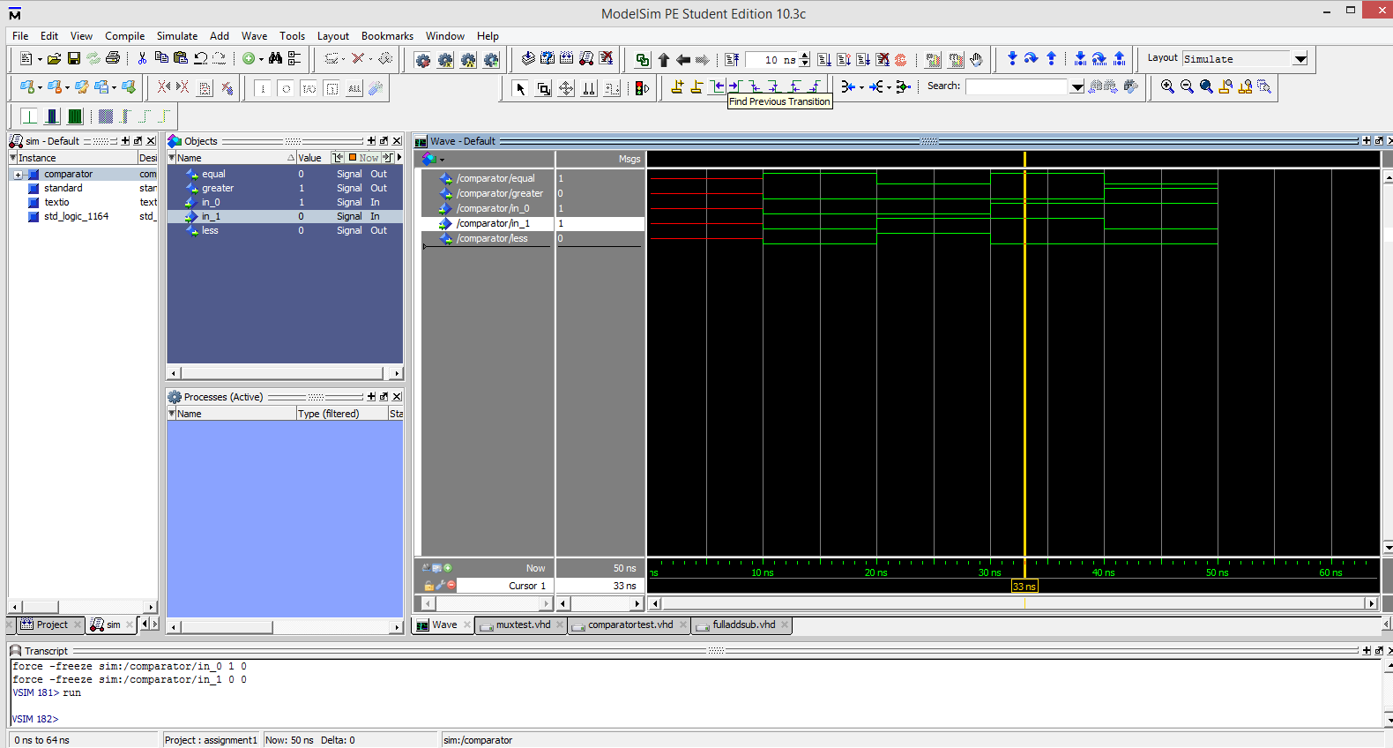

Encoder:

The encoder is a circuit that takes in a decimal number and transcribes it into a binary number.

Gate Truth Table

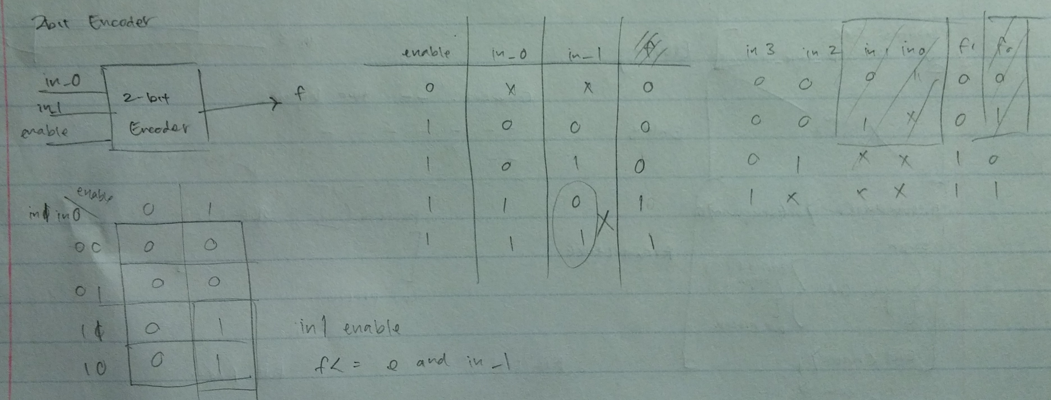

K- Map Boolean Equation

Wave Map:

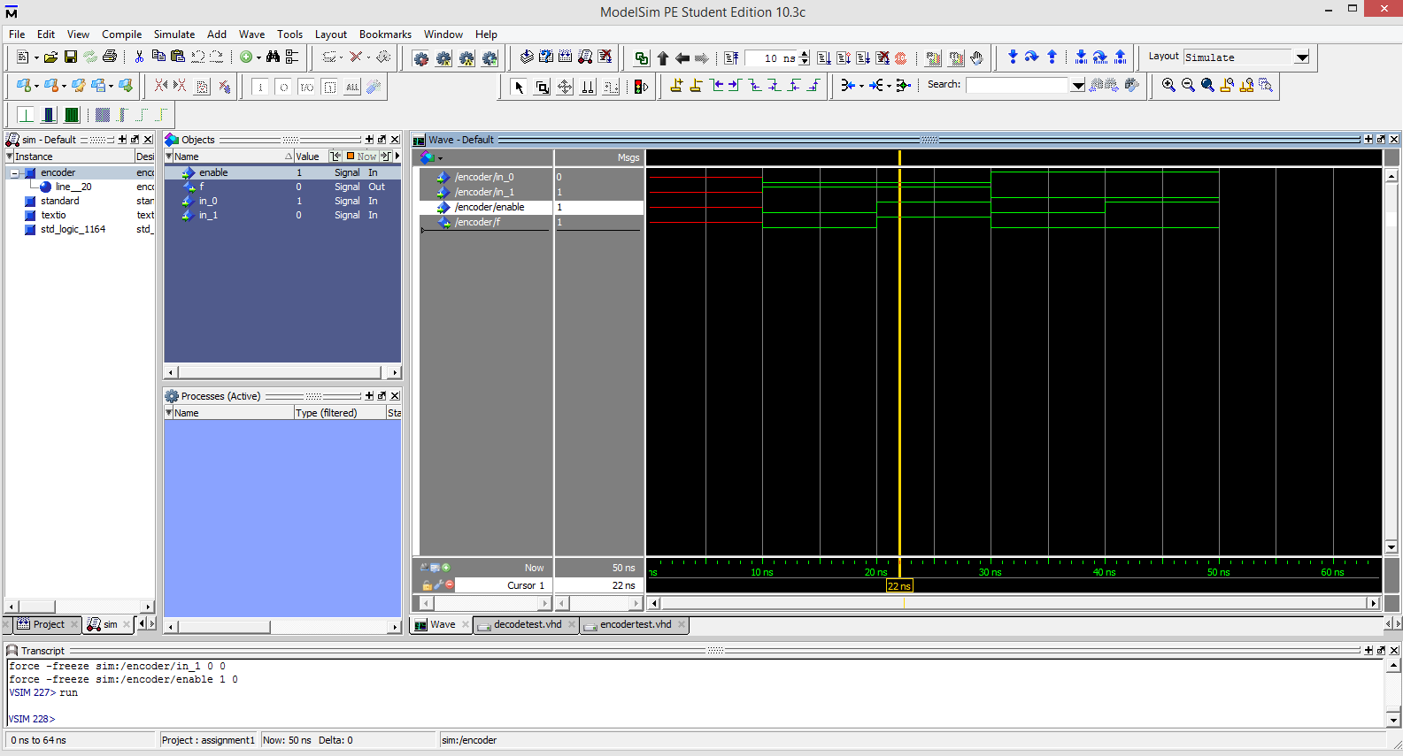

Decoder:

The decoder is a circuit that takes a binary number and transcribes it into a decimal number, It is the opposite of an encoder.

Gate Truth Table

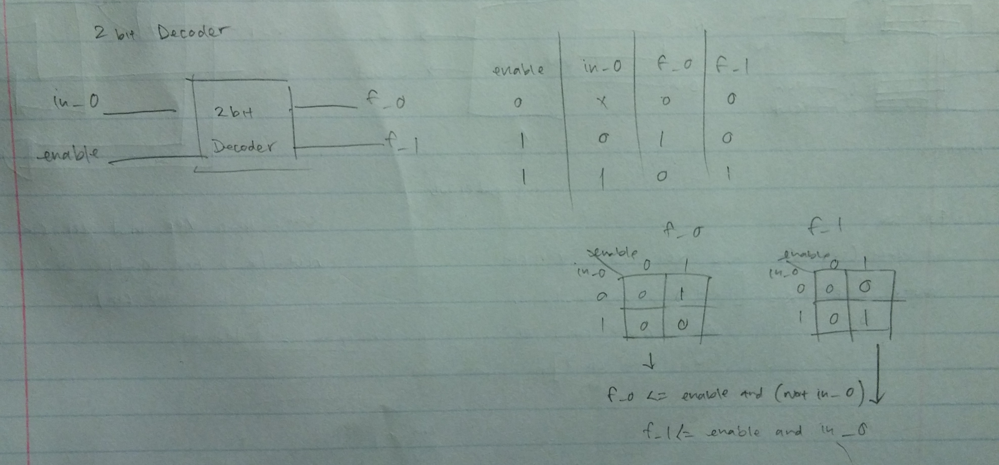

K- Map Boolean Equation

Wave Map:

